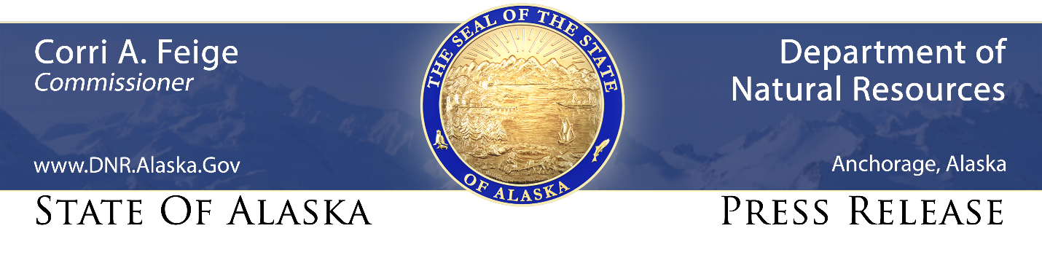
For Immediate Release: June 2, 2021

Agricultural Education Day set for June 11 at new bridge in Nenana

(Palmer, AK) – The Division of Agriculture is working to open up 140,000 acres of new agricultural land in Interior Alaska, and will hold an “Agricultural Education Day” on the land on Friday, June 11, next to the bridge in Nenana connecting the land with in-state markets.

In association with federal, state, local and tribal partners in the Nenana-Tokchaket land development project, the agricultural division will present a full day’s program of information and demonstrations on Interior agriculture in general, and the new land development.

The division’s tribal partners and representatives include Alaska Village Initiatives, the Intertribal Agriculture Council, and the Nenana Native Association, said division director David Schade.

“Nenana-Tokchaket is an exciting development that offers opportunities to expand our cropland resources, support new businesses, create new jobs, and enhance food security for our state,” Schade said. “We see this Agricultural Education Day as chance to give Alaskans a hands-on, informative day that brings the opportunities contained in this project to light for everyone.”

The day’s activities will focus on agricultural and natural resource education and program outreach. Live demonstrations will include:
- demonstrations of how digging soil pits provides valuable information about the soil’s potential and best uses
- using simulators to demonstrate how crops react to different types of rainfall
- showing how biomass and biochar can be used to enhance and enrich soil
- discussions on how farmers can best meet farm conservation planning requirements to protect natural resources during commercial operations

Division experts will staff booths offering information on the many state programs that advance the division’s mission to promote and encourage development of an agricultural industry in Alaska. The booths will cover topics including:
- the Alaska Plant Materials Center
- Alaska Grown marketing programs
- state land sale offerings
- agricultural grants
- invasive species detection, prevention and defense

The day’s program will take place from 10 a.m. to 5 p.m. at Nenana’s 10th Street boat launch -- the parking area adjacent to the new Nenana River bridge. The event is free and open to the public.

Completed last year by the Nenana Native Association with federal transportation funds, the bridge is an essential step in the agricultural division’s plans to make up to 140,000 acres available for development, with the first 33,000 acres to be offered over the next few years.

“Anyone interested in land, farming, and food security in Alaska is invited to come enjoy what promises to be a full day of hands-on learning and fun,” said Schade.

CONTACT: Erik Johnson, (907) 761-3863; erik.johnson@alaska.gov

###

STAY CONNECTED:
DNR Newsroom: http://dnr.alaska.gov/commis/dnr_newsroom.htm
DNR on Social Media: http://dnr.alaska.gov/commis/social_media.htm
DNR Public Information Center: http://dnr.alaska.gov/commis/pic/

